Module 6. Task 2.

lsnrctl status

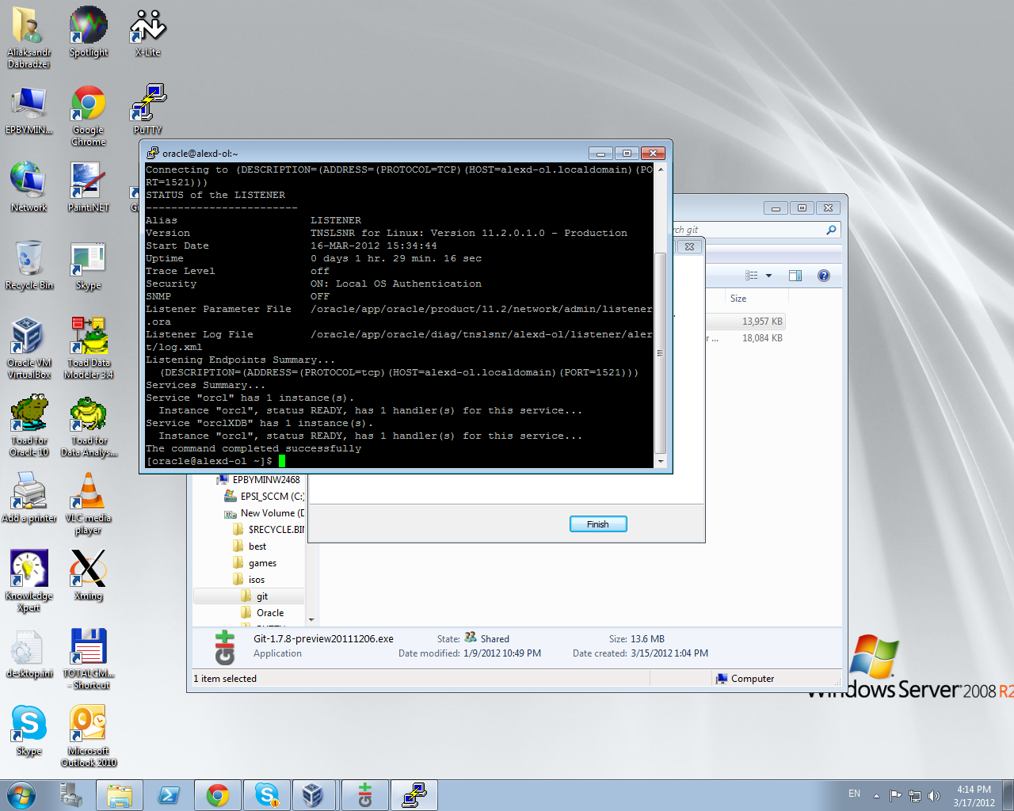

sqlplus / AS SYSDBA

SELECT \* FROM dual;

